JavaScript (2)
LATIHAN 3: Menambahkan Text Dan Date
Nama /Nim | : | Nur Muhammad FRJ (2418017)
Kelas | : | D
Pengajar | : | Ikhwaan Pratama (2418060)

Tujuan
- Praktikan dapat memahami struktur dasar JavaScript.
- Praktikan dapat memahami fungsi tag-tag dasar JavaScript.
- Praktikan dapat membuat halaman web menggunakan JavaScript.

Alat dan Bahan
- Laptop/pc
- Modul Praktikum Web 2026
- TextEditor (Visual Studio Code / Sublime Text)

Langkah-langkah
- Buat file (Admin.html)
Source Code :
<!DOCTYPE html>
<html lang="en">

<head>
<meta charset="UTF-8" />
<link rel="icon" href="assets/icon.png" />
<link rel="stylesheet" href="css/admin.css" />
<link href="https://unpkg.com/boxicons@2.0.7/css/boxicons.min.css" rel="stylesheet" />
<meta name="viewport" content="width=device-width, initial-scale=1.0" />
<title>Catshop Admin</title>
</head>

<body>
<div class="sidebar">
<div class="logo-details">
<i class="bx bx-category"></i>
<span class="logo_name">CatShop</span>
</div>
<ul class="nav-links">
<li>
<a href="#" class="active">
<i class="bx bx-grid-alt"></i>
<span class="links_name">Dashboard</span>
</a>
</li>
<li>
<a href="categories/categories.html">
<i class="bx bx-box"></i>
<span class="links_name">Categories</span>
</a>
</li>
<li>
<a href="transaction/transaction.html">
<i class="bx bx-list-ul"></i>
<span class="links_name">Transaction</span>
</a>
</li>
<li>
<a href="../Latihan Bab 1/index.html">
<i class="bx bx-log-out"></i>
<span class="links_name">Log out</span>
</a>
</li>
</ul>
</div>
<section class="home-section">
<nav>
<div class="sidebar-button">
<i class="bx bx-menu sidebarBtn"></i>
</div>
<div class="profile-details">
<span class="admin_name">Catshop Admin</span>
</div>
</nav>
<div class="home-content">
<h2 id="text"></h2>
<h3 id="date"></h3>
</div>
</section>
<script>
let sidebar = document.querySelector(".sidebar");
let sidebarBtn = document.querySelector(".sidebarBtn");
sidebarBtn.onclick = function () {
sidebar.classList.toggle("active");
if (sidebar.classList.contains("active")) {
sidebarBtn.classList.replace("bx-menu", "bx-menu-alt-right");
} else sidebarBtn.classList.replace("bx-menu-alt-right", "bx-menu");
};
function myFunction() {
const months = ["Januari", "Februari", "Maret", "April", "Mei",
"Juni", "Juli", "Agustus", "September", "Oktober",
"November", "Desember"];
const days = ["Minggu", "Senin", "Selasa", "Rabu", "Kamis",
"Jumat", "Sabtu"];
let date = new Date();
jam = date.getHours();
tanggal = date.getDate();
hari = days[date.getDay()];
bulan = months[date.getMonth()];
tahun = date.getFullYear();

let m = date.getMinutes();
let s = date.getSeconds();
m = checkTime(m);
s = checkTime(s);
document.getElementById("date").innerHTML = `${hari},
${tanggal} ${bulan} ${tahun}, ${jam}:${m}:${s}`;
requestAnimationFrame(myFunction);
}
function checkTime(i) {
if (i < 10) {
i = "0" + i;
}
return i;
}
window.onload = function () {
let nama = prompt("Masukkan Nama Anda : ", "Admin");
let jam = new Date().getHours();
if (nama != null) {
if (jam >= 4 && jam <= 10) {
document.getElementById("text").innerHTML = `Selamat Pagi ${nama}`;
} else if (jam >= 11 && jam <= 14) {
document.getElementById("text").innerHTML = `Selamat Siang ${nama}`;
} else if (jam >= 15 && jam <= 18) {
document.getElementById("text").innerHTML = `Selamat Sore ${nama}`;
} else {
document.getElementById("text").innerHTML = `Selamat Malam ${nama}`;
}
}
myFunction();
};
</script>
</body>

</html>

Hasil Tampilan :
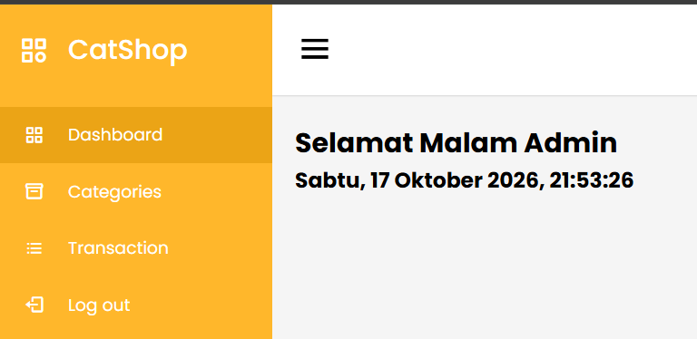

1.1 Tampilan Dashboard Admin

- Buat file (Index.html)
Source Code :
<!DOCTYPE html>
<html lang="en">

<head>
<link rel="icon" href="assets/icon.png" />
<title>Home</title>
<link rel="stylesheet" href="css/style.css" />
<link rel="preconnect" href="https://fonts.googleapis.com" />
<link rel="preconnect" href="https://fonts.gstatic.com" crossorigin />
<link
href="https://fonts.googleapis.com/css2?family=Poppins:wght@400;500;700&family=Roboto:wght@500;700&display=swap"
rel="stylesheet" />
<link rel="stylesheet" href="https://cdnjs.cloudflare.com/ajax/libs/font-awesome/5.15.3/css/all.min.css" />
</head>

<body>
<div class="container">
<header>
<nav>
<div class="logo">
<img src="assets/logo.png" alt="" />
</div>
<input type="checkbox" id="click" />
<label for="click" class="menu-btn">
<i class="fas fa-bars"></i>
</label>
<ul>
<li><a href="#">Home</a></li>
<li><a href="#">Categories</a></li>
<li><a href="login.html" class="btn_login">Login</a></li>
</ul>
</nav>
</header>
<main>
<div class="jumbotron">
<div class="jumbotron-text">
<h1>Find Your New Little Cat, Make a New Friend</h1>
<p> Teman barumu yang lucu menunggu mu, ayo temukan mereka sekarang
</p>
<button type="button" class="btn_getStarted">Get Started</button>
</div>
<div class="jumbotron-img">
<img src="assets/jumbotron.png" alt="" />
</div>
</div>
<div class="cards-categories">
<h2>Cat Categories</h2>
<div class="card-categories">
<div class="card">
<div class="card-image">
<img src="assets/anggora.png" alt="gambar tidak ditemukan" />
</div>
<div class="card-content">
<h5>Anggora</h5>
<p class="description">Anggora turki adalah salah satu ras kucing domestik alami tertua. Ras
ini berasal dari Ankara, Turki. Kucing ini sangat populer dan terkenal di Indonesia.</p>
<p class="price"><span>Rp.</span>1,000,000</p>
<button class="btn_belanja" type="submit" onclick="bukaModal('Anggora')">Beli</button>
</div>
</div>
<div class="card">
<div class="card-image">
<img src="assets/persia.png" alt="gambar tidak ditemukan" />
</div>
<div class="card-content">
<h5>Persia</h5>
<p class="description">Kucing persia adalah ras kucing domestik berbulu panjang dengan
karakter wajah bulat dan moncong pendek. Namanya mengacu pada kota Persia.</p>
<p class="price"><span>Rp.</span>1,500,000</p>
<button class="btn_belanja" type="submit" onclick="bukaModal('Persia')">Beli</button>
</div>
</div>
<div class="card">
<div class="card-image">
<img src="assets/british.png" alt="gambar tidak ditemukan" />
</div>
<div class="card-content">
<h5>British Shorthair</h5>
<p class="description">Kucing bulu pendek britania adalah salah satu ras kucing tertua di
inggris. Kucing ini adalah kucing berbadan sedang dengan bulu yang pendek. </p>
<p class="price"><span>Rp.</span>2,000,000</p>
<button class="btn_belanja" type="submit"
onclick="bukaModal('British Shorthair')">Beli</button>
</div>
</div>
<div class="card">
<div class="card-image">
<img src="assets/MaineCoon.jpeg" alt="gambar tidak ditemukan" />
</div>
<div class="card-content">
<h5>MaineCoon</h5>
<p class="description">MaineCoon Dikenal Sebagai Salah Satu Ras Kucing Terbesar. Meski Ukuran Tubhnya Jumbo,
Jenis Kucing Ini Dikenal Sangat Ramah, Pintar, Penyayang, Dan Sangat Suka Bermain Dengan Pemiliknya. </p>
<p class="price"><span>Rp.</span>4,000,000</p>
<button class="btn_belanja" type="submit" onclick="bukaModal('MaineCoon')">Beli</button>
</div>
</div>
</div>

</div>
<!-- Modal -->
<div id="myModal" class="modal-container" onclick="tutupModal()">
<div class="modal-dialog" onclick="event.stopPropagation()">
<div class="modal-content">
<div class="modal-header">
<h1 class="modal-title " style="color: #ffb72b;">Formulit Pembayaran</h1>
<button type="button" class="btn-close" aria-label="Close"></button>
</div>
<div class="modal-body">
<form>
<div class="form-group">
<label class="labelmodal" for="recipient-name" class="col-form-label">Nama :</label>
<input class="inputdata" type="text" class="form-control" id="recipient-name">
</div>
<div class="form-group">
<label class="labelmodal" for="handphone" class="col-form-label">No. Hp :</label>
<input class="inputdata" type="text" class="form-control" id="handphone">
</div>
<div class="form-group">
<label class="labelmodal" for="alamat-text" class="col-form-label">Alamat:</label>
<textarea class="inputalamat" class="form-control" id="alamat-text"></textarea>
</div>
</form>
</div>
<div class="modal-footer">
<button type="button" class="btn btn-secondary" onclick="tutupModal()">Keluar</button>
<button type="button" class="btn btn-yellow" onclick="bukaModal2()">Lanjutkan</button>
</div>
</div>
</div>
</div>
<!-- Modal 2 -->
<div id="myModal2" class="modal-container" onclick="tutupModal2()">
<div class="modal-dialog" onclick="event.stopPropagation()">
<div class="modal-content">
<div class="modal-header">
<h1 class="modal-title" style="color: #ffb72b;">Data Transaksi</h1>
<button type="button" class="btn-close" aria-label="Close" onclick="tutupModal2()"></button>
</div>
<div class="modal-body">
<form>
<h4> Kategori</h4>
<div class="form-group">
<label class="labelmodal" for="detail-kategori" class="col-form-label">Kategori
:</label>
<input class="inputdata" type="text" class="form-control" id="detail-kategori"
disabled>
</div>
<div class="form-group">
<label class="labelmodal" for="detail-harga" class="col-form-label">Harga :</label>
<input class="inputdata" type="text" class="form-control" id="detail-harga"
disabled>
</div>
<h4>Pembeli</h4>
<div class="form-group">
<label class="labelmodal" for="detail-nama" class="col-form-label">Nama :</label>
<input class="inputdata" type="text" class="form-control" id="detail-nama" disabled>
</div>
<div class="form-group">
<label class="labelmodal" for="detail-nomorhp" class="col-form-label">No. Hp
:</label>
<input class="inputdata" type="text" class="form-control" id="detail-nomorhp"
disabled>
</div>
<div class="form-group">
<label class="labelmodal" for="detail-alamat" class="col-form-label">Alamat:</label>
<textarea class="inputalamat" class="form-control" id="detail-alamat"
disabled></textarea>
</div>
</form>
</div>
<div class="modal-footer">
<button type="button" class="btn btn-secondary" onclick="kembaliKeModalPertama()">Kembali</button>
<button type="button" class="btn btn-yellow" onclick="lakukanPembayaran()">Lakukan
Pembayaran</button>
</div>
</div>
</div>
</div>

</main>
<footer>
<h4>&copy; Lab Pemrograman Komputer 2024</h4>
</footer>
</div>
<script>
// Fungsi Modal
function bukaModal(kategori) {
document.getElementById("myModal").style.display = "flex";

document.getElementById("kategori-detail").innerText = "Detail " + kategori;

document.getElementById("nama").value = "";
document.getElementById("nomorhp").value = "";
document.getElementById("alamat").value = "";
}

function tutupModal() {
document.getElementById("myModal").style.display = "none";
}

function tutupModal2() {
document.getElementById("myModal2").style.display = "none";
}
function bukaModal2() {
tutupModal(); // Tutup modal pertama
document.getElementById("myModal2").style.display = "flex";

var nama = document.getElementById("recipient-name").value;
var nomorhp = document.getElementById("handphone").value;
var alamat = document.getElementById("alamat-text").value;

document.getElementById("detail-nama").value = nama;
document.getElementById("detail-nomorhp").value = nomorhp;
document.getElementById("detail-alamat").value = alamat;
}
function kembaliKeModalPertama() {
tutupModal2();
bukaModal();
}
function lakukanPembayaran() {
alert("Pembayaran berhasil!");
tutupModal2();
}

</script>
</body>

</html>

- Ubah file (Style.css)
Source Code :
* {
margin: 0;
padding: 0;
box-sizing: border-box;
}

.container {
width: 80%;
margin: 0 auto;
}

body {
font-family: "Poppins", sans-serif;
}

/* new nav */
nav {
display: flex;
height: 80px;
width: 100%;
align-items: center;
justify-content: space-between;
flex-wrap: wrap;
}
nav ul {
display: flex;
flex-wrap: wrap;
list-style: none;
}
nav ul li {
margin: 0 5px;
}
nav ul li a {
color: #111;
text-decoration: none;
font-weight: 500;
padding: 8px 15px;
transition: all 0.3s ease;
}
nav ul li a.active,
nav ul li a:hover {
color: #ffb72b;
}
nav .menu-btn i {
color: #000;
font-size: 22px;
cursor: pointer;
display: none;
}
input[type="checkbox"] {
display: none;
}

.btn_login {
background-color: #ffb72b;
width: 100%;
padding: 8px 16px;
border-radius: 10px;
border: none;
cursor: pointer;
color: white;
}

.btn_login:hover {
background-color: #eba416;
color: #fff;
}

/* style jumbotron */
.jumbotron {
display: flex;
background-color: #ffb72b;
border-radius: 20px;
padding: 20px 0;
justify-content: space-around;
align-items: center;
margin-bottom: 50px;
}

.jumbotron-text {
width: 30%;
font-weight: 500;
}

.jumbotron-text p {
color: white;
margin: 20px 0;
}

.jumbotron-text button {
padding: 10px 18px;
border: none;
border-radius: 10px;
background-color: white;
color: #ffb72b;
cursor: pointer;
}

/* style card-categories */
.cards-categories {
display: flex;
flex-direction: column;
align-items: center;
}

.cards-categories h2 {
font-family: "Roboto", sans-serif;
font-size: 24px;
margin-bottom: 20px;
text-align: center;
}

.card-categories {
display: grid;
gap: 1.5rem;
grid-template-columns: repeat(auto-fit, minmax(20rem, 1fr));
}

.card {
box-shadow: 0 10px 20px rgba(0, 0, 0, 0.1);
border-radius: 15px;
overflow: hidden;
transition: transform 0.3s ease-in-out;
}

.card:hover {
transform: scale(1.05);
}

.card .card-image {
overflow: hidden;
border-radius: 15px 15px 0 0;
}

.card img {
width: 100%;
height: auto;
object-fit: cover;
border-radius: 15px 15px 0 0;
}

.card-content {
padding: 20px;
}

.card h5 {
margin-bottom: 10px;
font-family: "Roboto", sans-serif;
font-size: 22px;
font-weight: 600;
color: #333;
}

.card p.description {
font-size: 14px;
color: #666;
margin-bottom: 15px;
}

.card p.price {
font-size: 18px;
font-weight: bold;
color: #ffb72b;
margin-bottom: 15px;
}

.card .btn_belanja {
background-color: #ffb72b;
padding: 12px 20px;
border-radius: 8px;
border: none;
cursor: pointer;
color: white;
font-size: 16px;
transition: background-color 0.3s ease;
}

.card .btn_belanja:hover {
background-color: #eba416;
}

/* footer */
footer {
display: flex;
justify-content: center;
align-items: center;
margin: 40px 0;
}

/* style page login */

.center {
display: flex;
justify-content: center;
align-items: center;
height: 500px;
}

.form-login {
display: flex;
flex-direction: column;
align-items: center;
width: 30%;
background-color: white;
padding: 30px;
margin: 0 auto;
box-shadow: 0 6px 12px 4px rgba(0, 0, 0, 0.15);
border-radius: 10px;
}

.input {
width: 100%;
margin: 10px 0;
padding: 10px;
border-radius: 10px;
border: 1px solid rgb(148, 148, 148);
}

.link-register {
text-decoration: none;
margin-top: 10px;
}

/* Modal */
.modal-container {
display: none;
position: fixed;
top: 0;
left: 0;
width: 100%;
height: 100%;
background-color: rgba(0, 0, 0, 0.5);
justify-content: center;
align-items: center;
color: #000;
}

.modal-dialog {
width: 80%;
max-width: 500px;
background-color: #fff;
border: none;
border-radius: 10px;
box-shadow: 0 0 10px rgba(0, 0, 0, 0.2);
}

.modal-header {
border-bottom: none;
padding: 10px 20px;
display: flex;
justify-content: space-between;
align-items: center;
}

.modal-title {
margin: 0;
font-size: 1.2rem;
}

.btn-close {
font-size: 1.5rem;
background: none;
border: none;
cursor: pointer;
color: #000;
}

.modal-body {
padding: 20px;
}

.form-group {
margin-bottom: 20px;
}

.form-group .labelmodal {
display: block;
margin-bottom: 5px;
}

.form-group .inputdata,
.form-group .inputalamat {
width: 100%;
padding: 8px;
border: 1px solid #ccc;
border-radius: 5px;
}

.modal-footer {
border-top: none;
padding: 10px 20px;
display: flex;
justify-content: flex-end;
}

.btn-secondary,
.btn-yellow {
padding: 8px 16px;
border: none;
border-radius: 5px;
cursor: pointer;
color: #fff;

}

.btn-secondary {
background-color: #888;
margin-right: 10px;
}

.btn-yellow {
background-color: #ffb72b;
}

/* responsive */
@media screen and (max-width: 1023px) {
.modal-dialog {
width: 80%;
}
.container {
width: 100%;
margin: 0 auto;
}
/* navbar responsive */
nav {
padding: 0 40px 0 50px;
position: relative;
}

nav .menu-btn i {
display: block;
}
#click:checked ~ .menu-btn i:before {
content: "\f00d";
}
nav ul {
position: absolute;
top: 80px;
left: -100%;
background: rgba(0, 0, 0, 0.85);
width: 100%;
text-align: center;
display: block;
transition: all 0.3s ease;
}
#click:checked ~ ul {
left: 0;
}
nav ul li {
width: 100%;
margin: 40px 0;
}
nav ul li a {
width: 100%;
margin-left: -100%;
display: block;
font-size: 20px;
color: #fff;
transition: 0.6s cubic-bezier(0.68, -0.55, 0.265, 1.55);
}
#click:checked ~ ul li a {
margin-left: 0px;
}
nav ul li a.active,
nav ul li a:hover {
color: #ffb72b;
}

/* jumbotron responsive */
.jumbotron {
flex-direction: column-reverse;
border-radius: 0px !important;
justify-content: center;
}
.jumbotron-img img {
width: 100% !important;
}

.jumbotron-text {
width: 100% !important;
padding-left: 20px;
}

/* card-categories responsive */
.card-categories {
flex-direction: column;
gap: 20px;
margin: 0 10px;
}

.card {
width: 100% !important;
}

/* form-login responsive */
.form-login {
width: 80%;
}
}

Hasil Tampilan :
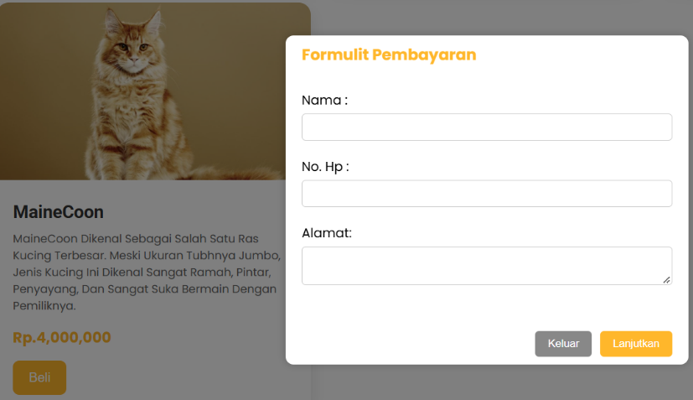

1.1 Tampilan Form Payment
Analisa:
Program pembuatan website CatShop ini dibangun dengan mengintegrasikan antarmuka dasbor admin berskemakan sidebar layout serta fitur interaktif berbentuk pop-up modal box untuk "Formulir Pembayaran". Dari aspek pemrograman web, dasbor memanfaatkan tata letak CSS untuk memisahkan menu navigasi utama (Dashboard, Categories, Transaction, Log out) di sisi kiri dan area konten di sisi kanan yang secara dinamis menampilkan sapaan serta waktu real-time, sementara pada tampilan produk (seperti ras MaineCoon), pemrogramannya memanfaatkan kombinasi HTML <form> dan JavaScript untuk memicu kemunculan jendela pop-up di atas latar belakang yang meredup (overlay) agar pengguna dapat mengisikan data pembelian tanpa harus berpindah halaman. Secara keseluruhan, desain ini tetap konsisten menggunakan identitas warna oranye khas CatShop serta elemen UI modern dengan sudut melengkung (border-radius) dan bayangan halus untuk meningkatkan pengalaman pengguna (user experience).

